October 1-2, 2022
Anniversary of the Dedication of the Church
Cantors: Sat. 5 pm Ray; Sun. 8:30 am Eileen; Sun. 10:30 am Glenn; Sun. 12:30 pm Amitha
Choirs: 5 pm Vigil Choir; 8:30 am Gregorian Chant; 10:30 am Chancel Choir; 12:30 pm Schola Cantorum

PRELUDE: Sat. 5 pm and Sun. 10:30 am – A House of Prayer (T. Alonso) ®
8:30 am – Deus in loco sancto suo (chant)® 12:30 pm – Locus Iste (A. Bruckner)®

INTROIT: I Will Go Up to the Altar of God (E. Feeley) octavo ®

KYRIE and GLORIA: from Mass of Spirit and Grace (R. Manalo) JS 195 – 196

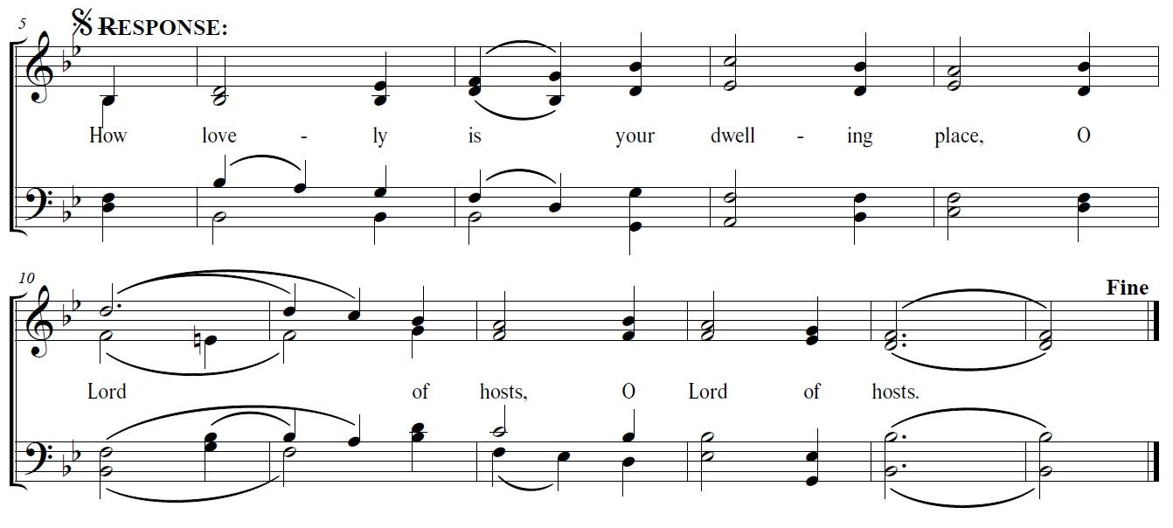
RESPONSORIAL PSALM: Psalm 84 – How Lovely is Your Dwelling Place (based on J. Brahms)

ALLELUIA: setting by Robert Twynham (with verses for Fall Ordinary Time Year C) (K)
God is spirit, and those who worship Him must worship in Spirit and truth.

OFFERTORY: Quis Sicut Deus? (A. Hill) Anniversary Hymn for St. Michael ®

MASS ACCLAMATIONS: from Mass of Spirit and Grace (with simple or solemn “Amen”) JS 199, 200, 204

COMMUNION ANTIPHON: The sparrow finds a home with you (O WALY WALY) music sheet ®

COMMUNION HYMN: Church of God, Elect and Glorious JS 508

POST-COMMUNION: Sat. 5 pm and Sun. 10:30 am – Tollite Hostias (C. Saint-Saens)®
8:30 am – Ierusalem quae aedificatur® 10:30 am – Exultate justi in Domino (L. da Viadana)®

RECESSIONAL HYMN: Holy God, We Praise Thy Name JS 566

** After Mass, please return all music so that it may be filed during the week**

