Mass of Christian Burial – Stephen Roland “Steve” Kilburn
10/14/1946 – 7/31/2025
Friday, August 8 2025 10:00 am
Fr. Scott – AH – MM – Resurrection Choir Livestream: YES Columbarium: K-50
Prelude | Amazing Grace JS 680
Entrance | How Great Thou Art JS 614, vs. 1 & 4
Resp. Psalm | 27 The Lord is my Light (on back)
Gospel Reading | Matthew 5: 1-12a
Gospel Acclamation | John Carroll Mass:  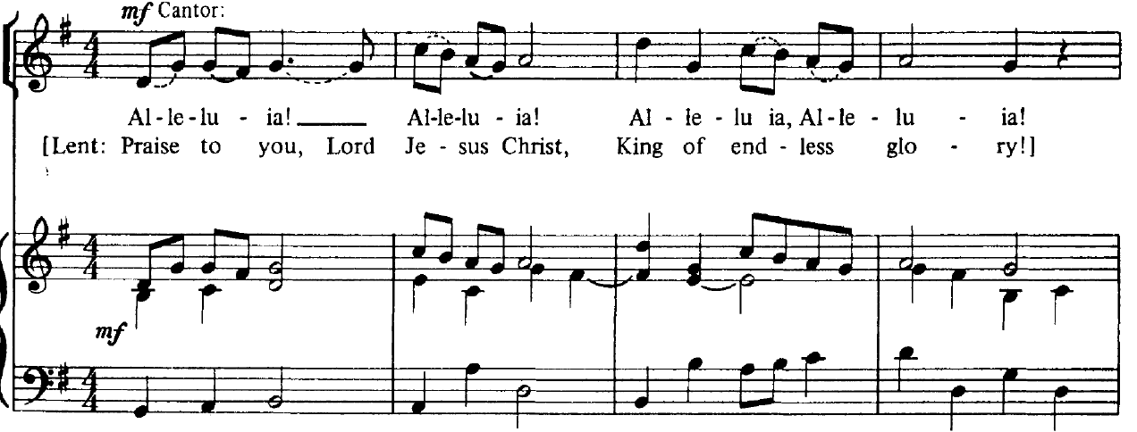
Prep. Of Gifts | Shepherd Me, O God (M. Haugen) - octavo
Holy | Heritage Mass: JS 227, 228, 231, 232
Communion Processional | Softly and Tenderly, Jesus is Calling JS 530
Song of Farewell | Song of Farewell JS 553 (verse 4)
Recessional | On Eagle’s Wings JS 671

